User Guide

By Jakub Panczyszyn

# Prerequisites:

A downloaded and extracted folder with the program code in it

# Step 1: Configure the game

Open up the folder with the game code, mine is called “Maze Game”:



Once you open that folder, there should be another one called “Maze Game” folder, open it.

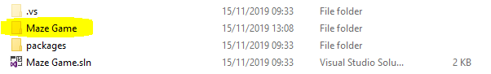

You should be greeted by the following sight.

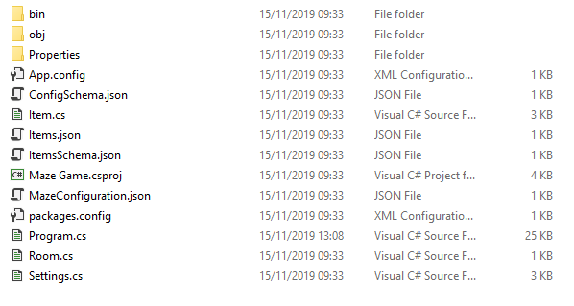

Open the MazeConfiguration.json file in a text editor by either doing this:

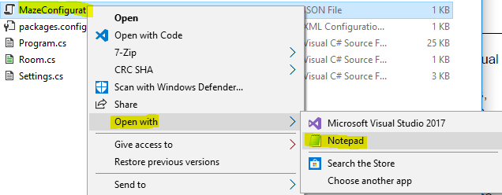

Or this:

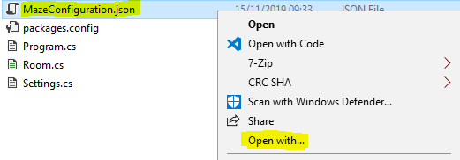

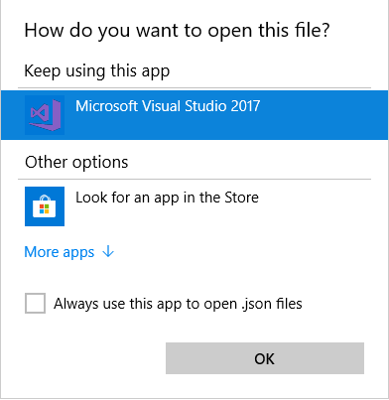

(If you see a notepad here, just click ok and proceed to the next step, if not click More apps and follow along)

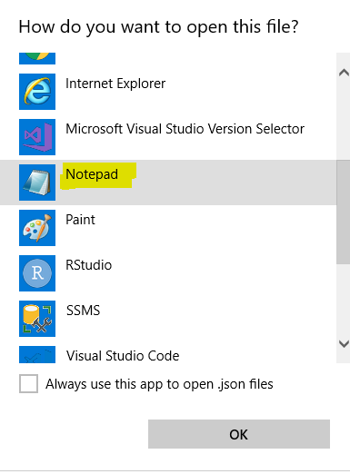

Click on the Notepad twice, or click ok after selecting it.

That file should be now opened in notepad, and you should see something like this

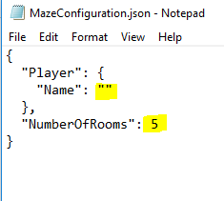

Put your nickname in between the highlighted quotation marks.

On the other hand, the NumberOfRooms option lets you pick how many rooms your maze is going to have, you can put any positive number you’d like.

Save and close the file.

# Step 2: Add Treasures, Threats

Once you are done with this file, there is another file called Items.json

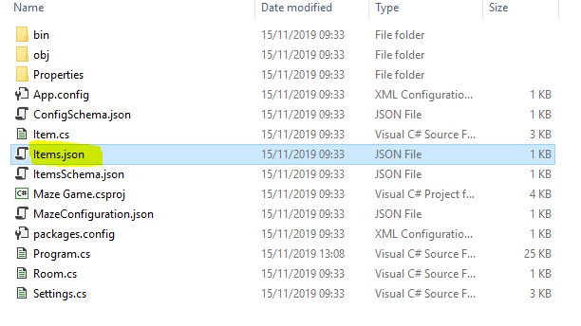

Open it up by repeating the same process as the previous file, and you should be greeted by the following screen

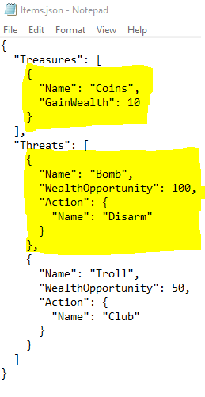

You can add treasures to the game by adding entries to the

“Treasures”: [

]

Since there already is one Treasure in there, you can add more by simply writing

{

“Name”: “Write Name of the Treasure Here”,

“GainWealth”: Number Here

}

Name sets the name of the treasure, whereas GainWealth sets how much wealth you will gain from the treasure in the game

Make sure that each { “Name”, “GainWealth” } object in “Treasures” is separated by a “,” (coma) apart from the last one.

You can also add “Threats” by adding entries to the

“Threats”: [

]

There should be already 2 Threats, so simply add

{

“Name”: “Write Name of the Threat Here”,

“WealthOpportunity”: number here

“Action”: {

“Name”: “Name of the Action that will defeat the Threat”

}

}

1st Name sets the name of the Threat

WealthOpportunity decides how much wealth you gain by defeating the Threat, but it also decides how much wealth you lose by losing to a Threat (you lose half of the WealthOpportunity value).

2nd Name sets the name of the Action that will defeat the Threat

Once you are done adding your Treasures and Threats to the game, you can save and close the file.

# Step 3: Start the game

Open the “bin” folder

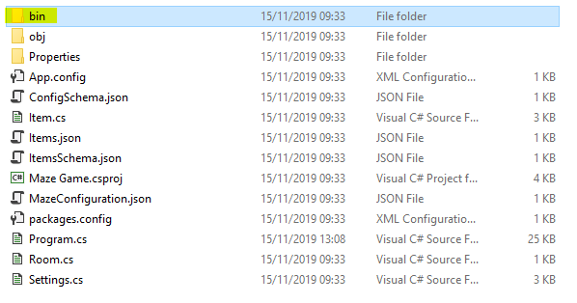

Open “Debug” folder



Start “Maze Game.exe” file.

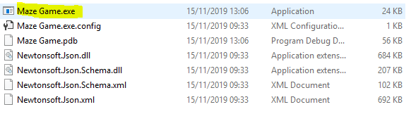

And now follow the instructions on the screen

# Step 4: Movement and mechanics

In order to move to other rooms, enter either: north, south, east, west.

If there isn’t a passage in the direction you wanted to go, the game will inform you by saying “You may not go that way”

You can also deposit your wealth in rooms by writing, for example, deposit 5, as long as you have enough Wealth, it should work. Use this method in order to mark the rooms you’ve already been to.

In order to take the Wealth from a room, enter withdraw 5, as long as you have left that much Wealth in the room, you should get it back.

When fighting Threats, you only have 3 chances to get the right action, if you fail, you will lose some of you Wealth, but if you get it right, you will gain Wealth.

You may exit the game at any time by typing “exit”

If you want to start a new game, just exit and start the “Maze Game.exe” file